Section 14 — What you will learn
This section has two main topics:
94–96
Host Patterns
↓
Choose which servers a playbook runs on

97–102
Include / Import
↓
Break one large playbook into smaller files
The big idea is:
Instead of putting everything into one huge playbook, we can select specific servers and split our work into multiple reusable YAML files.

First: Check your setup
On your CentOS controller:
ansible dev -m ping
Expected:
ansibleclient1 | SUCCESS
ansibleclient2 | SUCCESS
Also check your inventory:
cat /etc/ansible/hosts
You should have:
[dev]
ansibleclient1
ansibleclient2

94. Selecting Hosts with Host Patterns
A host pattern tells Ansible:
Which machines should I run this playbook against?
You currently have:
[dev]
ansibleclient1
ansibleclient2
So:
ansible dev -m ping
means:
Run the ping module against all hosts in dev.

Test 1 — Both servers
ansible dev -m ping
Both should respond.

Test 2 — Only ansibleclient1
ansible ansibleclient1 -m ping
Only:
ansibleclient1
will respond.

Test 3 — Only ansibleclient2
ansible ansibleclient2 -m ping
Only:
ansibleclient2
will respond.

95. Hands-On: Defining Ansible Host Patterns
Now let's create another inventory group.
Edit:
sudo vi /etc/ansible/hosts
Change it to:
[dev]
ansibleclient1
ansibleclient2

[webservers]
ansibleclient1

[dbservers]
ansibleclient2
Save:
ESC
:wq
Enter
Now you have:
dev
├── ansibleclient1
└── ansibleclient2

webservers
└── ansibleclient1

dbservers
└── ansibleclient2

Check inventory
Run:
ansible-inventory --graph
You should see something similar to:
@all
|--@dev
| |--ansibleclient1
| |--ansibleclient2
|--@webservers
| |--ansibleclient1
|--@dbservers
|--ansibleclient2

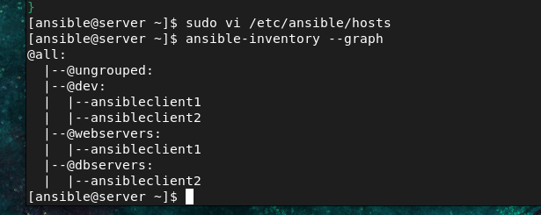

Test webservers
ansible webservers -m ping
Only:
ansibleclient1
should respond.

Test dbservers
ansible dbservers -m ping
Only:
ansibleclient2
should respond.
This is the basic concept of host patterns.

96. Hands-On: More Host Patterns
You can also specify multiple hosts.
For example:
ansible "ansibleclient1:ansibleclient2" -m ping
This targets both servers.
You can also use the group:
ansible dev -m ping
For your current lab, the most useful patterns are:
ansible ansibleclient1 -m ping
ansible ansibleclient2 -m ping
ansible dev -m ping
ansible webservers -m ping
ansible dbservers -m ping

97. Including and Importing Files
Now the second major topic starts.
Imagine you create one huge playbook:
main.yml
with:
Install Apache
Create HTML
Create users
Configure firewall
Copy files
Configure SSH
Configure database
It can become very difficult to maintain.
Instead, we can split it:
main.yml
apache.yml
users.yml
firewall.yml
files.yml
Then main.yml can call the smaller files.

98. Include vs Import
There are two important Ansible concepts:
include
import
The simple difference for your learning is:

Import
Static
Ansible loads the file when the playbook is processed.
Example:
import_tasks: apache.yml

Include
Dynamic
The file is included while the playbook is running.
Example:
include_tasks: apache.yml
For now, remember:
import_tasks
↓
static

include_tasks
↓
dynamic

99. Import_playbook in Ansible
There is another important command:
import_playbook
This is used to call another complete playbook.
Example:
main.yml
|
+── apache.yml
|
+── database.yml

Let's make a real project
We will create:
ansible-complex/
│
├── main.yml
├── apache.yml
├── files.yml
└── index.html

Step 1 — Create project directory
On CentOS:
mkdir -p ~/ansible-complex
Go inside:
cd ~/ansible-complex
Check:
pwd

100. Hands-On 1 — Include and Import Files — Apache Setup
Let's install Apache on ansibleclient1.
Remember our inventory:
[webservers]
ansibleclient1

Step 2 — Create Apache playbook
vi apache.yml
Put:

---
- name: Install Apache
hosts: webservers
become: yes

tasks:

- name: Install Apache
apt:
name: apache2
state: present
update_cache: yes

- name: Start Apache
service:
name: apache2
state: started
enabled: yes
Save:
ESC
:wq
Enter

Step 3 — Run it
ansible-playbook apache.yml
This installs Apache only on:
ansibleclient1

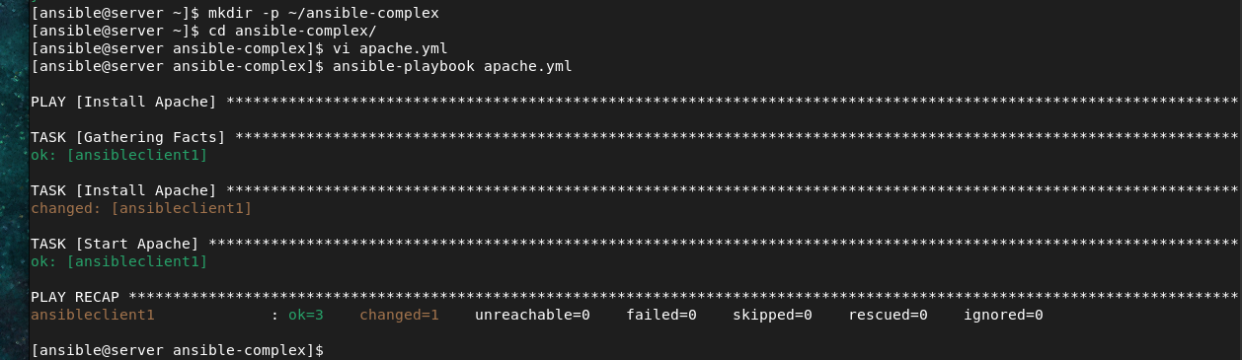

Step 4 — Check Apache
ansible webservers -m shell -a "systemctl status apache2 --no-pager"
Or simply:
ansible webservers -m command -a "systemctl is-active apache2"
Expected:
Active
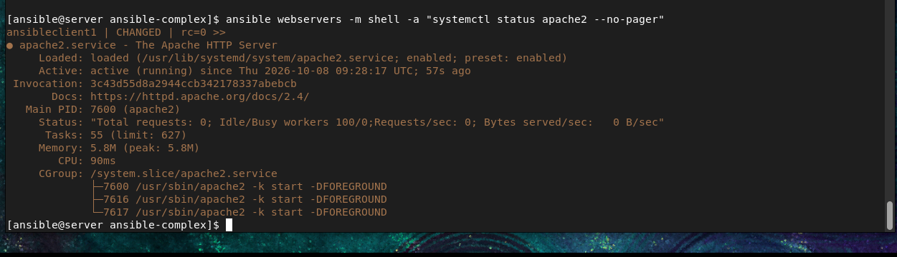

Create HTML file
Create:
vi index.html
Put:
<!DOCTYPE html>
<html>
<head>
<title>Ansible Apache Server</title>
</head>
<body>
<h1>Hello from Ansible</h1>
<p>Apache was configured using Ansible.</p>
</body>
</html>
Save.

Create files.yml
vi files.yml
Put:
---
- name: Configure Apache webpage
hosts: webservers
become: yes

tasks:

- name: Copy index page
copy:
src: index.html
dest: /var/www/html/index.html
mode: '0644'
Run:
ansible-playbook files.yml



101. Hands-On 2 — Include and Import Files — Apache Setup
Now instead of running the two playbooks separately, create a main playbook.
Create:
vi main.yml
Put:
---
- import_playbook: apache.yml
- import_playbook: files.yml
Now run:
ansible-playbook main.yml
Ansible will do:
main.yml
|
+---- apache.yml
| |
| └── Install Apache
|
+---- files.yml
|
└── Copy index.html
This is the purpose of:
import_playbook

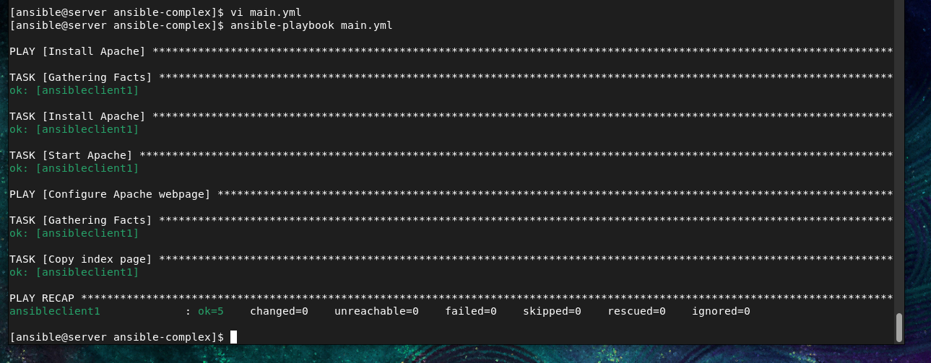

Step 102. Hands-On 3 — Include and Import Files
Now let's use include_tasks.
Instead of creating separate complete playbooks, we can create task files.
Create:
vi install-apache.yml
Put:
---
- name: Install Apache
apt:
name: apache2
state: present
update_cache: yes

- name: Start Apache
service:
name: apache2
state: started
enabled: yes
Notice this file does not contain:
hosts:
because it is a task file, not a complete playbook.

Create another task file:
vi copy-page.yml
Put:
---
- name: Copy website page
copy:
src: index.html
dest: /var/www/html/index.html
mode: '0644'
Now create:
vi include-main.yml
Put:
---
- name: Apache configuration using include
hosts: webservers
become: yes

tasks:

- name: Include Apache installation tasks
include_tasks: install-apache.yml

- name: Include website tasks
include_tasks: copy-page.yml
Run:
ansible-playbook include-main.yml

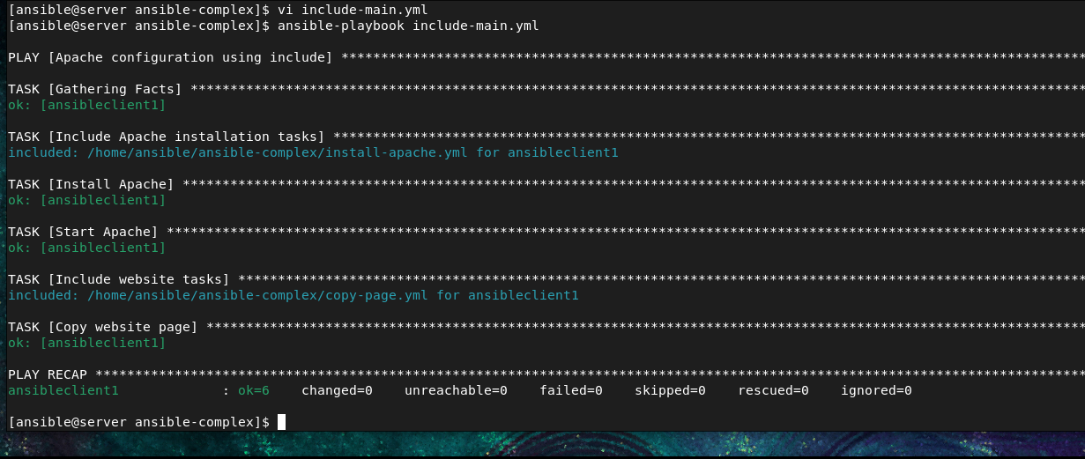

Verify the website
Because Apache is installed on:
ansibleclient1
get its IP:
ansible ansibleclient1 -m setup -a "filter=ansible_default_ipv4"
Or:
ansible ansibleclient1 -m shell -a "hostname -I"
Then from your browser:
http://PUBLIC-IP-OF-ansibleclient1
You should see:
Hello from Ansible
Apache was configured using Ansible.
Make sure the AWS Security Group allows:
TCP
Port 80
Source: 0.0.0.0/0
for this lab.

Complete Section 14 structure
Your directory will eventually look like:
~/ansible-complex/
│
├── main.yml
├── apache.yml
├── files.yml
├── include-main.yml
├── install-apache.yml
├── copy-page.yml
└── index.html

Very important concepts to remember

Host Pattern
Controls WHERE the playbook runs.
hosts: webservers
means:
Run on webservers group

import_playbook
Calls another complete playbook.
- import_playbook: apache.yml

import_tasks
Calls a task file statically.
Example:
tasks:
- import_tasks: install-apache.yml

include_tasks
Calls a task file dynamically.
Example:
tasks:
- include_tasks: install-apache.yml

